KVKK Compliance for Log360
Strengthen data protection and meet KVKK compliance with Log360.
Region: Turkey | Type: Data Privacy | Category: Compliance | Pricing: Free

Overview
The KVKK compliance extension in Log360 helps organizations meet KVKK — Personal Data Protection Law No. 6698 (Turkey, 2016), enforced by the KVKK Board for all controllers processing Turkish residents' personal data by providing centralized log management, breach detection, and compliance reporting. The platform supports KVKK requirements for access control, security audit logging, breach detection and notification, data encryption monitoring, network security, privileged access management, third-party processor controls, and data retention lifecycle management across cloud and on-premise environments.
For Technical & Organizational Security Measures (Article 12), Log360 delivers system-wide monitoring across AD logon, Windows events, and audit log reports to evidence that active security measures are in place and operating. To address Access Control & Authorization Management (Article 12, 6), the platform monitors AD logon events, Windows logon/logoff, failed access attempts, Unix logon, and remote session activity to enforce minimum-privilege access to personal data systems. The extension also supports Security Audit Logging & Audit Trails (Article 12) by providing capabilities that maintains EventLog reports, Windows system events, user auditing records, and GPO audit logs as the primary evidence base for demonstrating security control effectiveness to KVKK auditors.

Key Features
- Personal Data Breach Detection & Notification (Article 12(5)): Log360 provides real-time Windows threat detection, network attack reports, antivirus events.
- Data Encryption & Sensitive Data Protection (Article 12, 6): Log360 monitors registry changes, security policy modifications, file operations, and USB storage activity to detect encryption policy violations and unencrypted data handling.
- Network Security & Intrusion Monitoring (Article 12): Log360 monitors network device attack reports, security traffic, Windows firewall threats, and firewall audit events to provide continuous network-layer visibility against intrusion attempts.
- Privileged Access Management (Article 12): Log360 monitors OU management, password auditing, GPO policy changes, user group changes, and user account modifications to detect privilege escalation and admin access misuse.

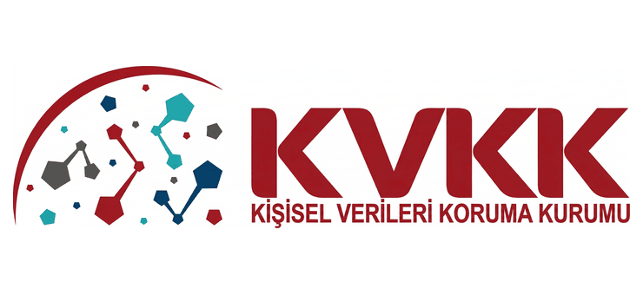
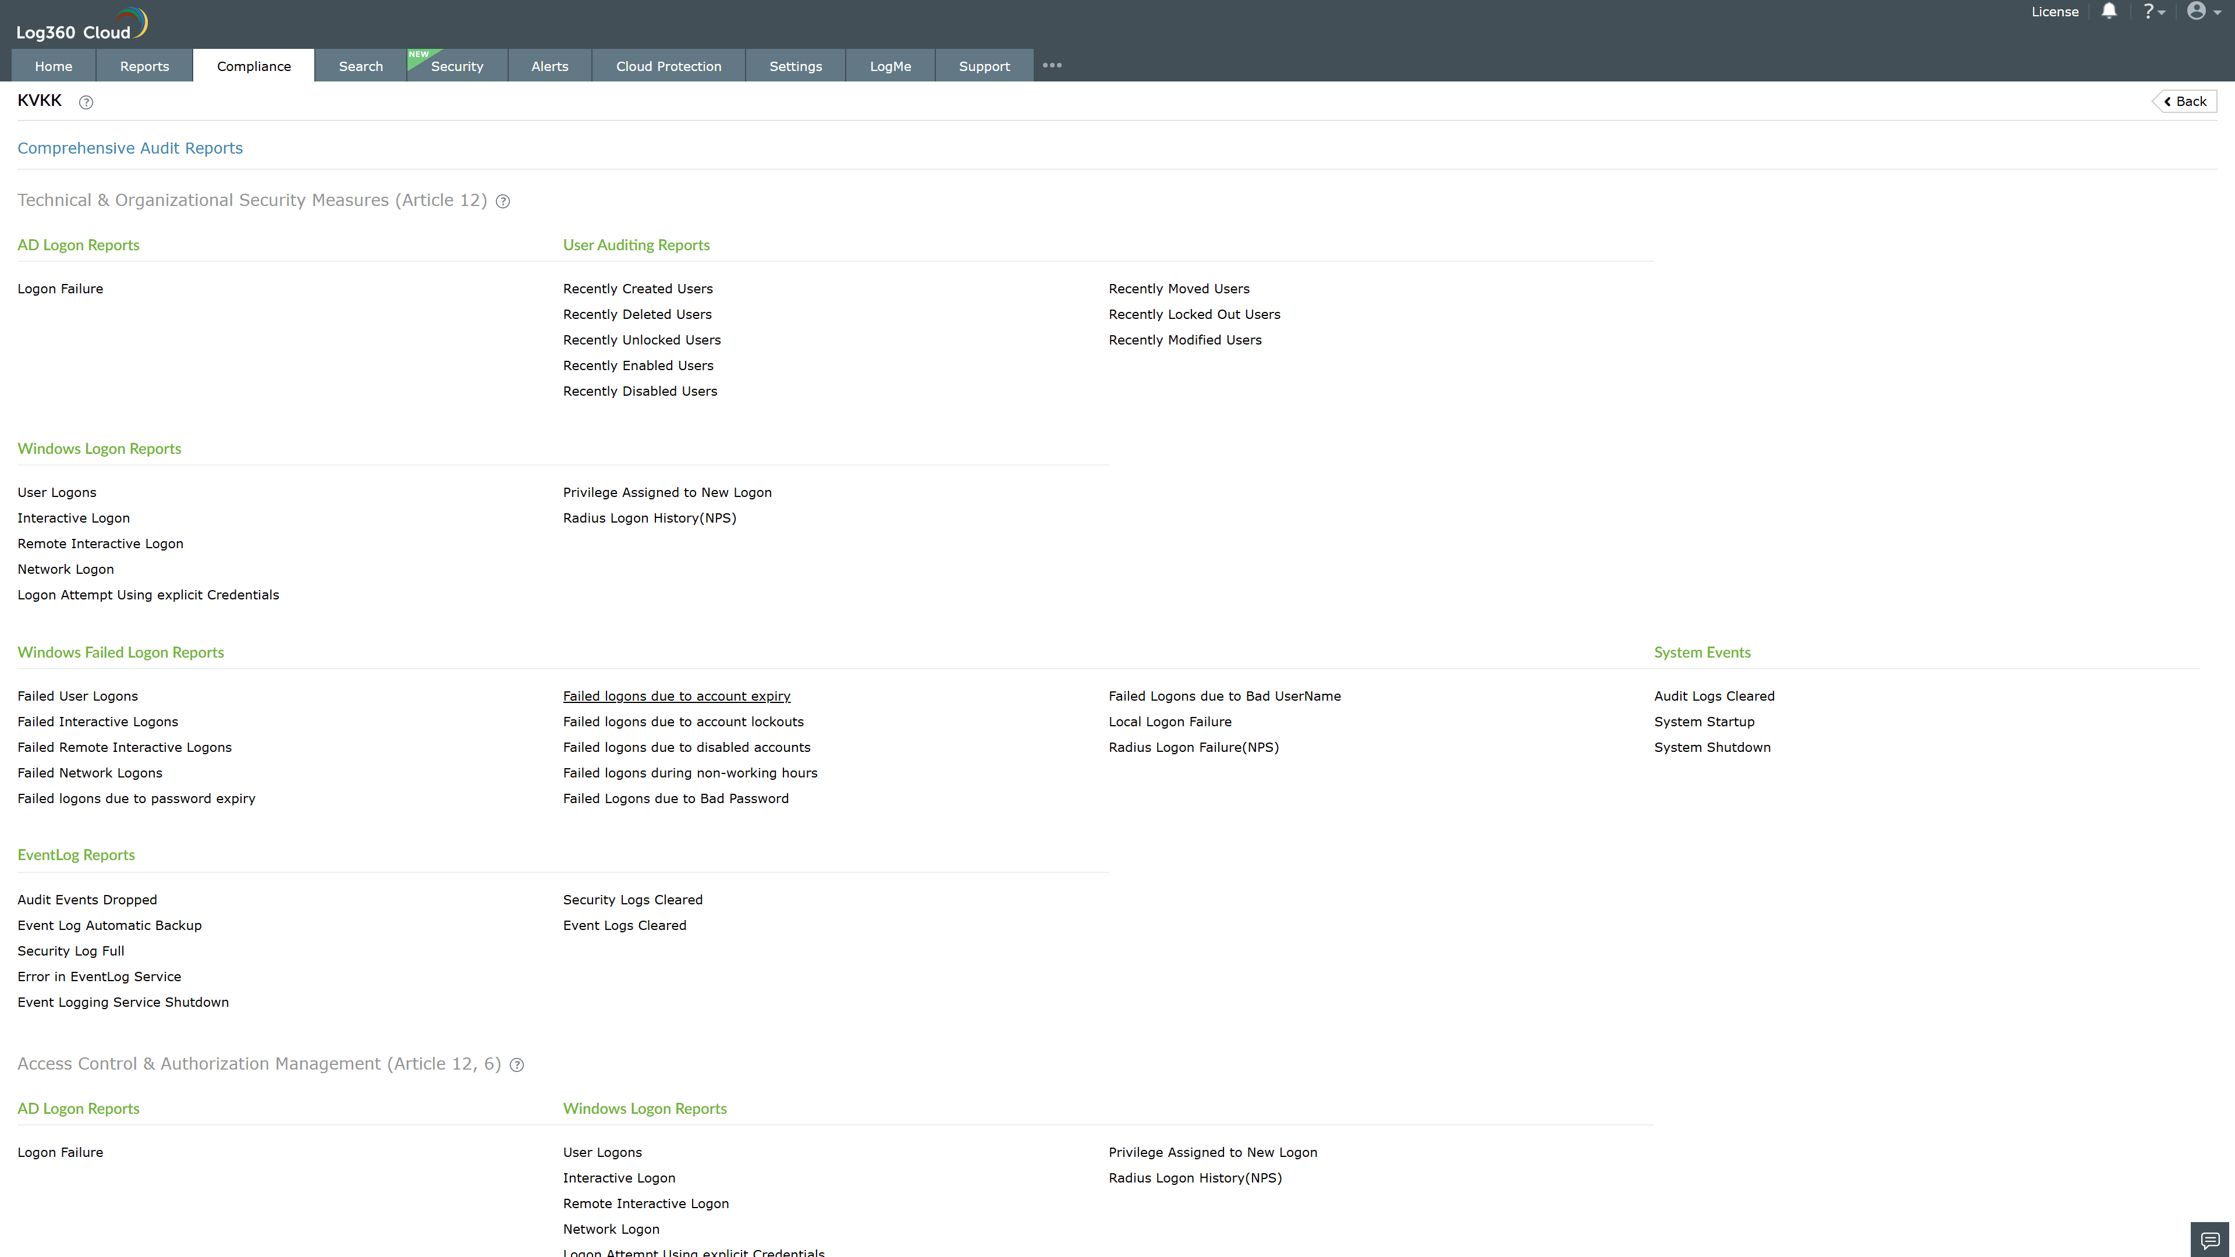
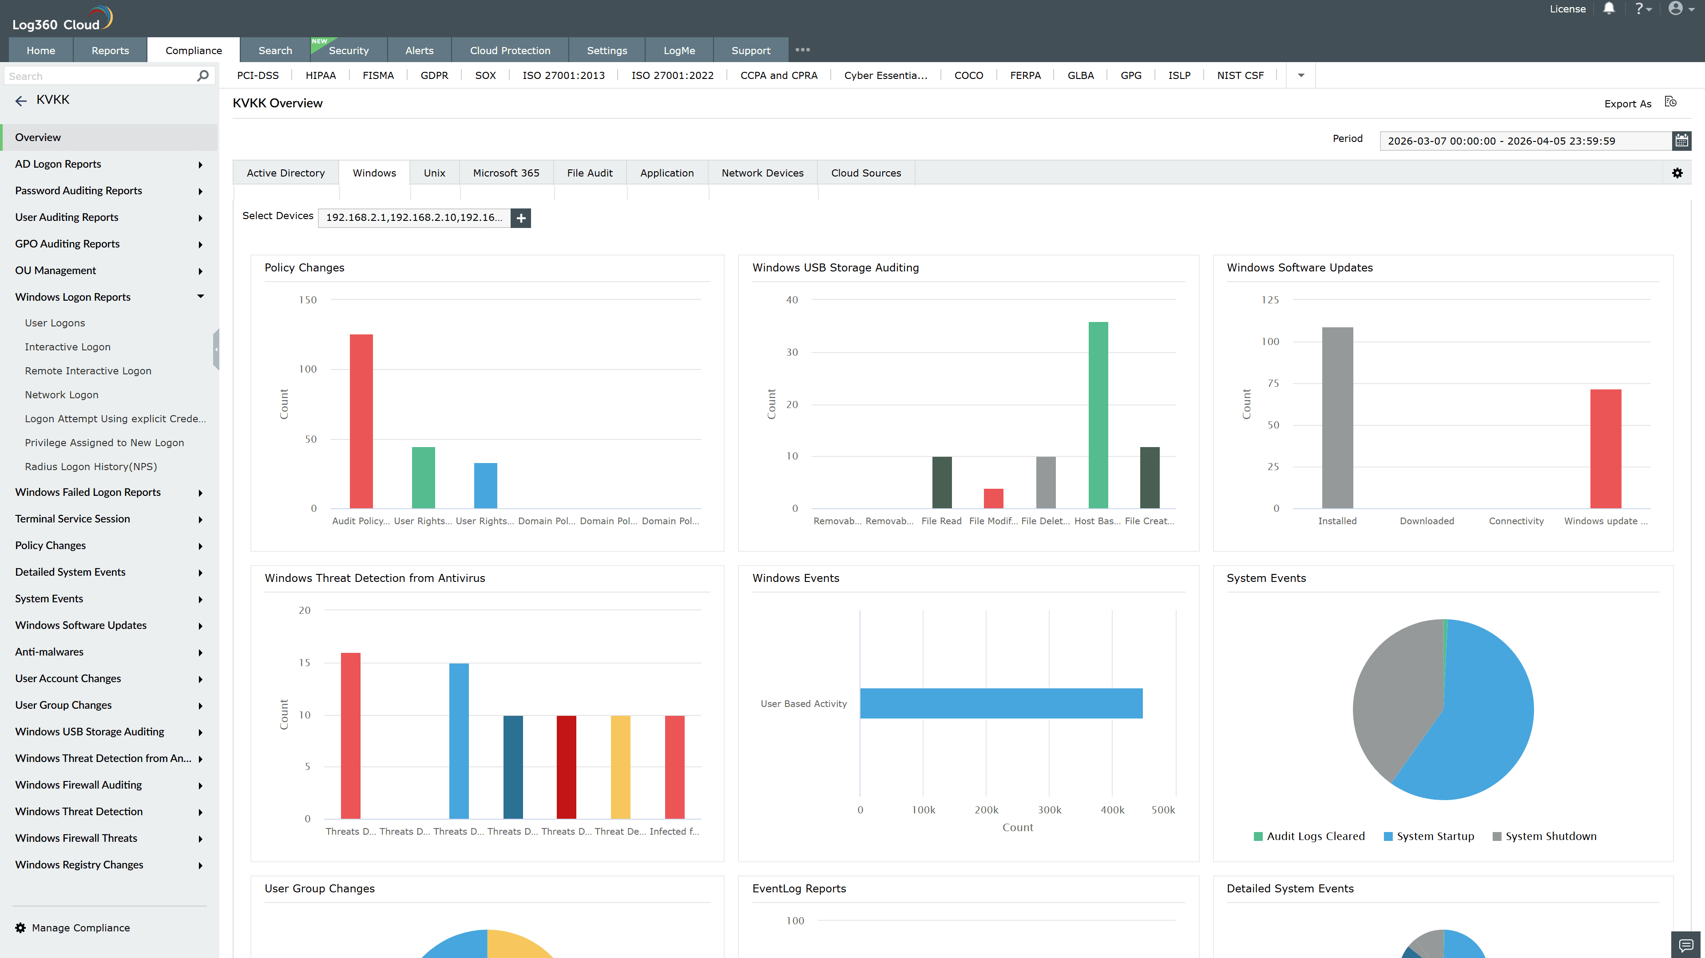
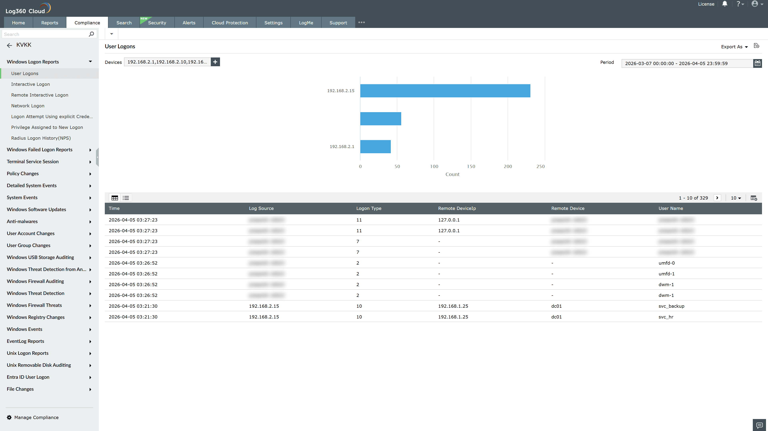
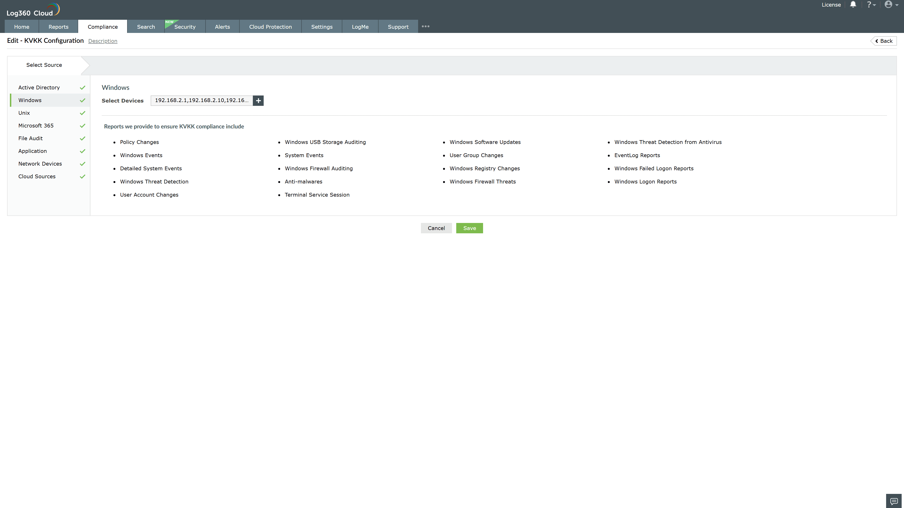
Valid Submission : Yes
Supported Editions : Free, Basic, Standard, Professional, MSSP
Help Document : https://www.manageengine.com/log-management/help/integrations/compliance-extensions.html
Help Video : Not provided
Tags : Log360, Compliance, Privacy monitoring, Data privacy, Regulatory compliance
Supported DCs : US, IN, JP, CA, AU, UK and EU
Privacy Policy:
Terms of Service:
Release Notes:
Predefined reports for the KVKK.

